**BEIJING JIAOTONG UNIVERSITY**

**SCHOOL OF SOFTWARE ENGINEERING**

**Ecopilot: A Web-Based Decision Support System for Economic Evaluation in Software Projects**

**Course : Software Engineering Economics**

**Instructor : Dr. Zhijiang Chen**

**Group Members : Zhuoxin Yao (ID:24126417)**

**Tianshu Zhao (ID:24126428)**

**Nuoxin Cheng (ID:24126369)**

**Jonathan Vigin (ID:24129093)**

**Submission Date: June 14th, 2025**

1. **Project Overview**

This project aims to develop an interactive Web application that integrates multi-dimensional economic analysis capabilities. It provides precise cost estimation, budget management, risk assessment, and resource optimization support throughout the software project life-cycle, supporting economic analysis and decision-making. The core objective of the tool is to assist project teams in making data-driven decisions, enhancing the efficiency of economic feasibility analysis, and reducing decision-making costs.

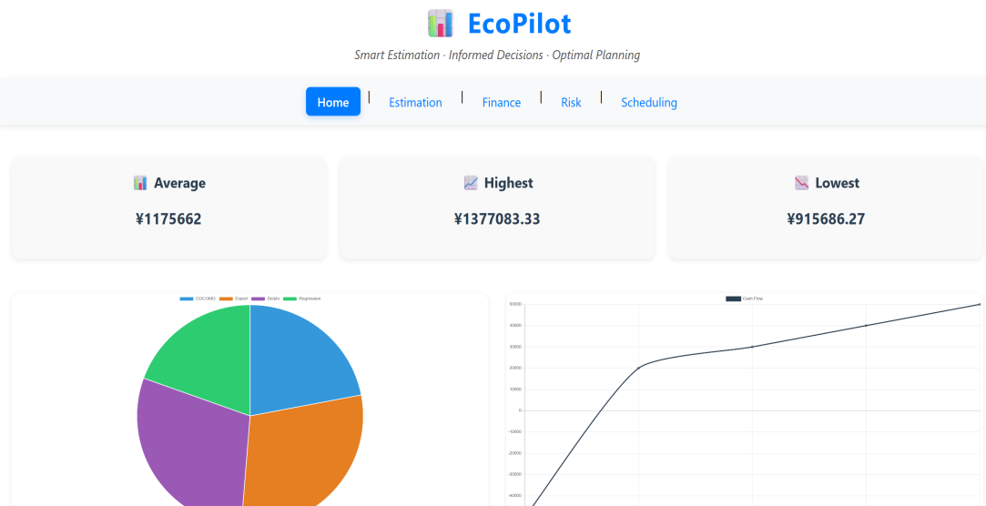

Fig 1 Homepage

1. **Target users**

Software project Manager: used for initial cost planning, budget allocation, resource scheduling and risk control of the project, and assist in making project decisions.

Economic analyst: Use tools to calculate economic indicators such as ROI and NPV, and complete the economic feasibility assessment of the project by combining sensitivity analysis, Monte Carlo simulation and other methods.

Development team members: understand the project cost structure and resource requirements, optimize development schedule and resource utilization efficiency.

1. **Overview of tools**

This tool is an interactive Web application with multi-dimensional economic analysis functions. Its core functions are divided into four different modules:

**Cost estimation module**,integrates various estimation models such as COCOMO and function point analysis, and supports multi-dimensional cost prediction and result comparison.**Finance** **module**,provides the calculation of economic indicators such as ROI, NPV and IRR, and realizes budget tracking, variance analysis and cost forecasting.**Risk management module**,through sensitivity analysis, decision tree, Monte Carlo simulation and other technologies, the risk probability and financial impact are quantified and visualized.**Scheduling module**,Use resource balance and smoothing algorithm to support scenario analysis to balance cost, schedule and resource input.

1. **System environment**

The tool adopts the architecture of front-end and back-end separation. The front end is based on vue to realize the visual interactive interface, and the back end is completed by Python and fastapi to complete data processing and model calculation, which supports Chart.js to realize the intuitive display of analysis results.

1. **Core module functions and graph user interface(GUI)**
2. **Cost estimation module**

This module focuses on the cost pre-assessment of software projects, integrating five methods: **COCOMO, function point analysis, expert estimation, Delphi method, and regression models.** COCOMO estimates workload based on code size (KLOC) and project patterns; function point analysis counts business elements to convert them into KLOC; expert estimation averages data from multiple individuals; the Delphi method converges results through multiple rounds of anonymous feedback; regression models use historical data to fit predictive equations.

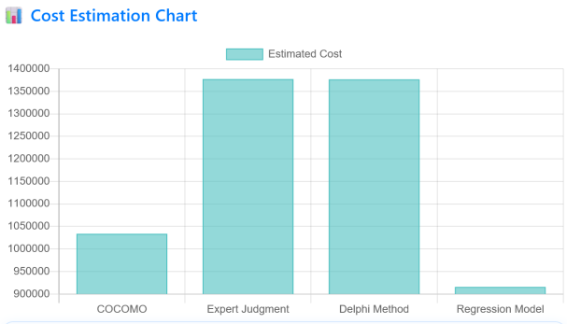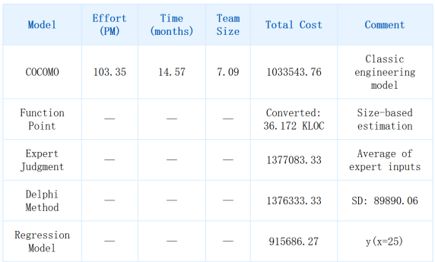

Fig 2 Cost Page

1. **Finance module**

Regarding the project's cash flow, **calculate key financial indicators such as NPV, ROI, and IRR. NPV** uses the discount rate to calculate the net present value of each period's cash flows, assessing the project's long-term value. ROI measures the efficiency of returns by comparing total revenue with costs. IRR identifies the internal rate of return that makes the net present value equal to zero, evaluating the project's intrinsic profitability. The system supports the reuse of cost estimation results to link initial investments, combined with custom parameters, for single project feasibility assessments and multi-option comparisons, aiding in capital investment decisions.

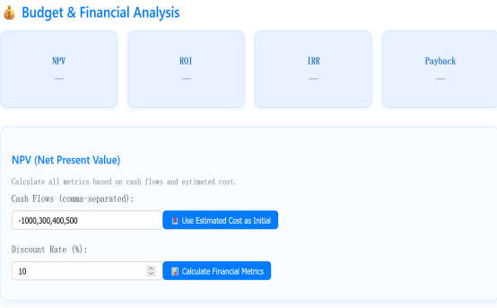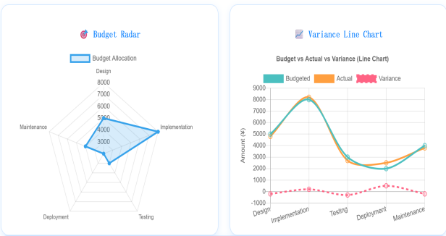

Fig 3 Finance Page

1. **Risk management module**

Construct a three-dimensional risk assessment system that **includes sensitivity analysis, decision trees, and Monte Carlo simulation.** Sensitivity analysis inputs baseline values and ranges of variation, outputs curves showing changes in indicators, and identifies key variables affecting project benefits; decision trees add paths, set probabilities and gains and losses, to quantify the outcomes of multi-branch decisions; Monte Carlo simulation, through extensive random sampling, outputs the probability distribution of indicators. From identifying key risks, quantifying probabilistic impacts, to simulating distribution trends, this system comprehensively reveals potential threats and opportunities, supporting risk response strategies.

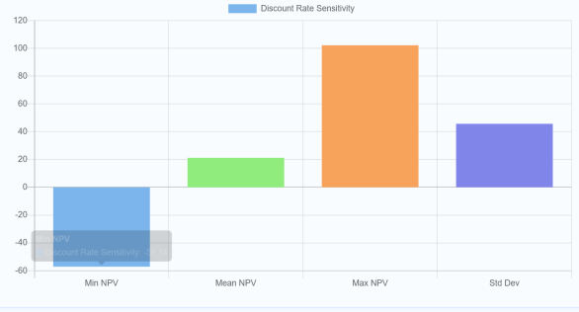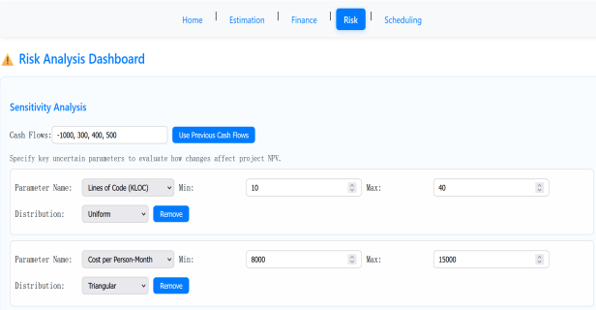

Fig 4 Risk Page

1. **Scheduling module**

It integrates **resource scheduling, task scheduling and resource smoothing functions.** Task scheduling optimizes the execution sequence and allocation by entering the task name, duration and resource requirements, and explores the critical path to compress the duration; resource smoothing sets the total resources and time slots under a fixed duration to balance the peak and valley of resource use.

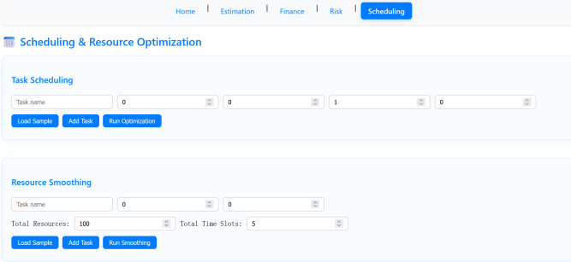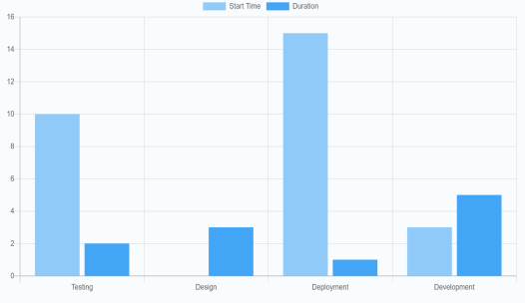

Fig 5 Scheduling Page

1. **Detailed explanation of core technologies**
2. **Cost estimation module**

**The COCOMO model** defines parameters based on the project model(**organic, semi-**

**independent, or embedded**)and calculates the workload by combining the code size (KLOC) with the effort adjustment factor (EAF). The EAF encompasses six factors, including reliability (RELY) and complexity (CPLX), each assigned a weight according to its level.**Function point analysis**,function points are calculated by statistics of external input, output and other business elements, and then converted into KLOC according to the language conversion coefficient, which is connected with the COCOMO model.Regression model,**the prediction equation is fitted based on historical project data**, supports multiple variable input, and solves the parameters by least squares method.**Expert estimation and Delphi method,**The weighted average algorithm is adopted, in which the Delphi method converges the results through multiple rounds of anonymous feedback, and the weight can be customized.

1. **Finance module**

**Economic index calculation,**use mathematical formulas to calculate net present value (NPV), return on investment (ROI), internal rate of return (IRR) and other indicators.**Budget tracking**,Cost deviation is judged by percentage variance, and the threshold is set to ±10%.Cost forecasting,based on historical data using exponential smoothing method,The formula is, Where the growth rate is fitted to historical trends by linear regression.

1. **Risk management module**

**Sensitivity analysis**,The technical implementation is a single variable traversal test. For example, for KLOC and parameters, the values are iterated in the range of 10-40 with a step length of 5, and the NPV corresponding to each value is calculated to generate a fluctuation curve.**Monte Carlo simulation**,The input includes parameters such as the benchmark value, distribution type and number of iterations; the output results include the probability distribution histogram, mean, percentile and high return probability of the simulated NPV.

1. **Scheduling module**

**Resource Balancing and Smoothing Algorithm**,The greedy scheduling algorithm prioritizes tasks based on their deadlines and assigns them to the earliest available time slots, ensuring that low-priority tasks do not prematurely consume resources. The output includes the start and end times of each task, along with a list of unassigned tasks. **The resource smoothing algorithm** evenly distributes the workload across time slots within a fixed period, ensuring that the resource usage in any single slot does not exceed 120% of the average capacity.